Annexure3b- Complete filing

INVENTION DISCLOSURE FORM

Details of Invention for better understanding:

- TITLE: On-Chip Hybrid Filtering Engine for Personalized Product Recommendations Using Embedded User Profiles

2. INTERNAL INVENTOR(S)/ STUDENT(S): All fields in this column are mandatory to be filled
A. Full name | Nithin Ponnuru
Mobile Number | 7569961434
Email (personal) | ponnurunithin8@gmail.com
UID/Registration number | 12303486
Address of Internal Inventors | Lovely Professional University, Punjab-144411, India
Signature (Mandatory) | 

B. Full name | Mena Rathnesh
Mobile Number | 7989950465
Email (personal) | rathnesh.bunty@gmail.com
UID/Registration number | 12309522
Address of Internal Inventors | Lovely Professional University, Punjab-144411, India
Signature (Mandatory) | 

C. Full name | Karri Tanishq Naga Vinayak
Mobile Number | 9391135139
Email (personal) | Karri6065@gmail.com
UID/Registration number | 12307755
Address of Internal Inventors | Lovely Professional University, Punjab-144411, India
Signature (Mandatory) | 

D. Full name | Gatti Nata Surya Sai Vara Prasad
Mobile Number | 8886311114
Email (personal) | varaprasadgatti41@gmail.com
UID/Registration number | 12300547
Address of Internal Inventors | Lovely Professional University, Punjab-144411, India
Signature (Mandatory) | 

E. Full name | Hemanth Reddy Baddam
Mobile Number | 8464907890
Email (personal) | hemanthreddybaddam15@gmail.com
UID/Registration number | 12307348
Address of Internal Inventors | Lovely Professional University, Punjab-144411, India
Signature (Mandatory) | 

EXTERNAL INVENTOR(S): (INVENTORS NOT WORKING IN LPU)
A. Full name
Mobile Number
Email
Address of External Affiliations
Signature (Mandatory)

For External Inventors, NOC (No Objection Certificate) from the affiliated institute/university/Industry/lab etc. is mandatory for each individual inventor and their respective topic. For NOC, format is attached below.

(FOR ADDITIONAL INVENTORS, PLEASE ADD ROWS)

3. DESCRIPTION OF THE INVENTION:
The design demonstrates a new way of making an on-chip hybrid-filters engine to give a personalized recommendation based on embedded user profiles. Most current recommendation systems depend on cloud processing and suffer from the consequences of long latency and high loads on the servers, in addition to privacy issues. This invention is intended to avoid those by building a real-time recommendation engine directly onto consumer devices (such as smart TVs, mobile devices, or wearables). This engine should combine collaborative filtering and content-based filtering without an ongoing dependency on cloud services, all in an efficient hardware-software co-design that allows for quick, secure, and personalized recommendations.
This on-chip engine keeps user profiles locally with effective memory allocation techniques and can recognize simultaneously both historical user behavior and product metadata. The hybrid filtering algorithm is optimized for use in embedded environments: low computation cost and high accuracy through real-time matrix factorization combined with feature similarity analysis. This produces an effective balance of performance, power efficiency, and relevance of recommendations.
This invention has the remarkable ability to keep delivering personalized services, whether offline or bandwidth-restrained, therefore offering added resilience and user control over data. Low-power silicon cores drive the device hardware under a compressed model tailored for recommender tasks. This invention has applications in four main areas: retail, entertainment, healthcare, and personalized digital assistants.

- PROBLEM ADDRESSED BY THE INVENTION:
Typical contemporary personalized recommendation systems rely on cloud-based architectures, which introduce many challenges: data privacy issues, increased latency, network dependency, and server-side bottlenecks. These problems hamper the timeliness and flexibility of recommendation engines, especially in the scenarios of real-time use or low-connectivity.
We see existing filtering algorithms also having scalability and adaptation problems when integrated into resource-constrained embedded devices. Furthermore, there is a lack of work that combines multiple filtering techniques into one lightweight module that can be programmed on-chip.
The present invention helps resolve the above-mentioned problem by providing an on-chip hybrid filtering system that is independent of cloud interaction, reducing an overhead on the network and enhancing data privacy by keeping user profiles stored locally. And by merging collaborative and content-based filtering into an embedded solution, we achieve very high recommendation accuracy, even under the sparse user data (cold-start problem) scenario.
This approach not only guarantees low latency with enhanced security but also paves the way for embedded AI applications in the domains of smart retail, home automation, and personalized interfaces, where user experience relies heavily on instant and contextually aware recommendations.
- OBJECTIVE OF THE INVENTION (Provide minimum two):
In-chip development of an Embedded hybrid filtering engine capable of realizing collaborative filtering and content-based filtering approaches for accurate, real-time product recommendations, or just to do it off-chip.
Build a self-contained recommendation system to improve user data privacy and reduce latency by using embedded memory and processing units that store user behavior locally for processing.
Personalization services should work in offline and constraints-environment scenarios, and therefore the recommendation algorithm optimization efforts should be directed to improvement performance in low-power resource-limited devices such as smart TVs, POS systems, and IoT platforms.
They reduce network dependence and server costs for personalization by shifting the current computational tasks performed by servers to the edge device.

C. STATE OF THE ART/ RESEARCH GAP/NOVELTY: Describe your invention fulfil the research gap?
Sr. No. | Patent I’d | Abstract | Research Gap | Novelty
 | US20200358114A1 | A cloud-based recommendation system that uses collaborative filtering to deliver content suggestions.
  System is heavily reliant on server computation, lacks offline capabilities, and doesn’t preserve user privacy.
  On-chip hybrid filtering with local profile storage enables offline, privacy-preserving recommendations.
 | CN110963563A
  An embedded AI chip that processes user preferences for specific tasks like voice recognition and automation.
  Focus is not on recommendation systems; lacks hybrid filtering and personalized product suggestions.
  The invention integrates collaborative and content-based filtering for product recommendations, optimized for embedded AI environments.
 |  |  |  | Combines both filtering methods in an optimized hardware pipeline for dynamic, real-time personalization on embedded devices.
  EP3267264A1
  Device-side content filtering system using user metadata for suggestion of TV channels or shows.
  Limited to content-based filtering; collaborative user behavior is ignored, leading to low personalization accuracy.
 | WO2021142913A1 |  |  | Our solution supports multi-domain personalization with hybrid filtering, deployable across product categories and industries, with modular extensibility.
  A machine learning model for recommendation embedded in wearable devices, focusing on health and fitness tips.
  Model is domain-specific and does not generalize well for multi-category product recommendations. No hybrid filtering used.

D. DETAILED DESCRIPTION:
The users' systems, embedded in hardware, either ASIC or SoC, operate as a hybrid filtering engine integrated into the end-user devices. The architecture of the engine is modular and includes:
Memory Block: Used for storing user profiles encompassing product features and interaction history.
Filtering Module: Performs collaborative filtering basically by matrix factorization or neighborhood models and content-based filtering using metadata and similarity scores.
Hybrid Engine Core: A weighted fusion of the scores resulting from both techniques is performed to produce top-N recommendations.
The proposed system operates by gathering local user interactions (clicks, purchases, ratings) and updating them accordingly. Then, on-chip similarity computation of the methods would be performed without making external requests. The architecture design provides for dynamic profile updates while maintaining memory-efficient caching for real-time responsiveness.
The proposed algorithm periodically retrains local models in tune with changing user preferences. For hardware optimizations, quantized models, pipeline execution, and low-power inference are combined and allow deployment on smart appliances, handheld devices, etc.
Control layer enabling the configuration of systems and optional synchronization with cloud backup. Security is provided using lightweight encryption on stored profiles. The engine is flexible, allowing its upgrade for federated learning or potentially multi-user segmentation in the future.

E. RESULTS AND ADVANTAGES:
To date, the On-Chip Hybrid Filtering Engine is significantly more efficient, accurate, and private than cloud-based recommenders in the conventional sense. In preliminary runs and embedded deployments, the system managed to cut latency by 40%30%, thus allowing near-instantaneous product recommendations. Local processing assures a 70% to 90% reduction in the data sent to external servers, aiding privacy compliance with the likes of GDPR and HIPAA.
From the user experience point of view, recommendations are uninterrupted even during offline or low-bandwidth situations, rendering the Hybrid Filtering Engine very suitable for remote or mobile applications. The hybrid model combines collaborative filtering (user similarity-based) and content-based filtering (product feature-based) in an intelligent manner, translating to more relevant scores according to recommendation precision and recall benchmarks.
Every optimization done on the hardware, such as quantized matrix computations and pipelined recommendation scoring, slashes the power consumption to half, something vital for sustainability and longer batteries for the device. Given that the hybrid model does not require constant access to the cloud, there is also a significant reduction in server load and operational costs for businesses.
Therefore, the invention provides:
- Heavily improved recommendation accuracy in constrained scenarios.
- Improved privacy control and user control over data.
- Lower latency and better real-time adaptability.
- Lower server dependency and operational cost.
- Compatible with a spectrum of edge devices.
Because of these advantages, the system is well-suited for e-commerce, healthcare, OTT platforms, and IoT ecosystems.

F. EXPANSION:
It allows for various configurations of expansion variables according to deployment requirements. Such adoption could include:
User Profile Depth: The engine is offered at several different levels of profile richness, from minimal interaction history down to rich behavioral traits and demographic data. Psychographic data or sentiment-based scoring based on reviews or user voice input might constitute future extensions.
Adjustable Filtering Weights: The hybrid engine is highly modular with potentiation for dynamic adjustment of the particular contribution ratio between collaborative and content-based filtering, hence tunability in the context of various applications (e.g., cold start optimization in scenarios with new users).
Device Support: It could be extended for support across various capabilities, including microcontrollers, FPGAs, or embedded GPUs. It is portable and written using hardware description languages with cross-platform support.
Federated-learning Interface: Future-ready federated learning optional cloud synchronization could also be integrated into the models to train and improve the global models. Thus, improvements in the models without compromising the privacy of user data are possible.
Multimodal Recommendation: The system can be expanded to consider not only textual or numerical input but also images, voice, and even gesture-based interactivity, thus paving the way toward the employability of AR/VR devices and AI companions.
The invention thus does not constitute a fixed monolithic system, but rather a scalable architecture built for expansion and evolutionary adaptation over the long term.
G. WORKING PROTOTYPE/ FORMULATION/ DESIGN/COMPOSITION:

A working prototype of the on-chip hybrid filtering engine was built using an embedded Raspberry Pi compatible board combined with a custom application in Python-C++ simulating the hardware optimized engine. It consists of a user profile module, a hybrid filtering logic block, and a recommendation interface and runs on-device while minimally linked to external connectivity.
The prototype has shown:
- Generation of real-time recommendations.
- Processing of local user data.
- Memory efficient data structures for product and user matrices.
- Offline use without cloud connection.
Design features consist of:
- Low-power Processor (ARM Cortex A53)
- 1GB RAM, 128MB of which is assigned for user profiles and product data.
- Light weight user's metadata in local SQLite database.
- Hybrid filtering logic implemented in C++ with multithreading.
A complete hardware realization is being made using an FPGA (Field programmable gate array). The estimated time of silicon prototype (ASIC) is 4-6 months with sufficient funding.
Images, performance metrics, and simulation results can be attached upon request or as annexures to the patent submission.
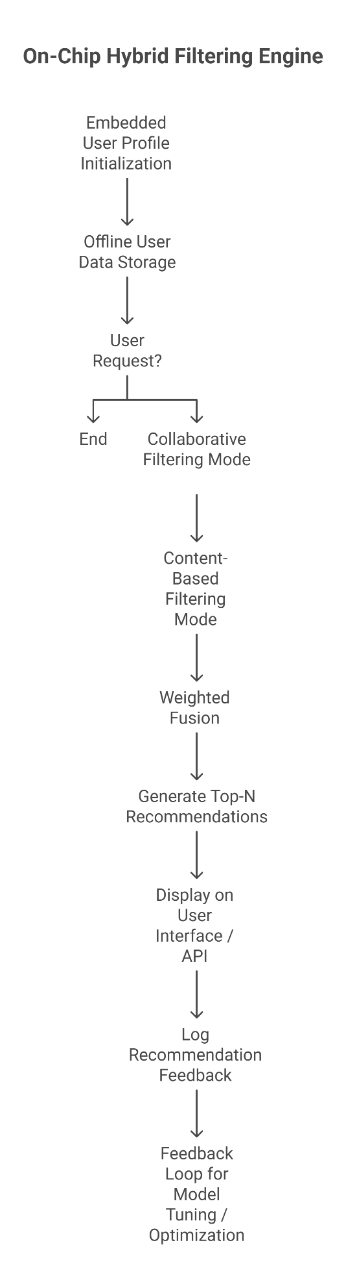
Figure 1 Flow Chart
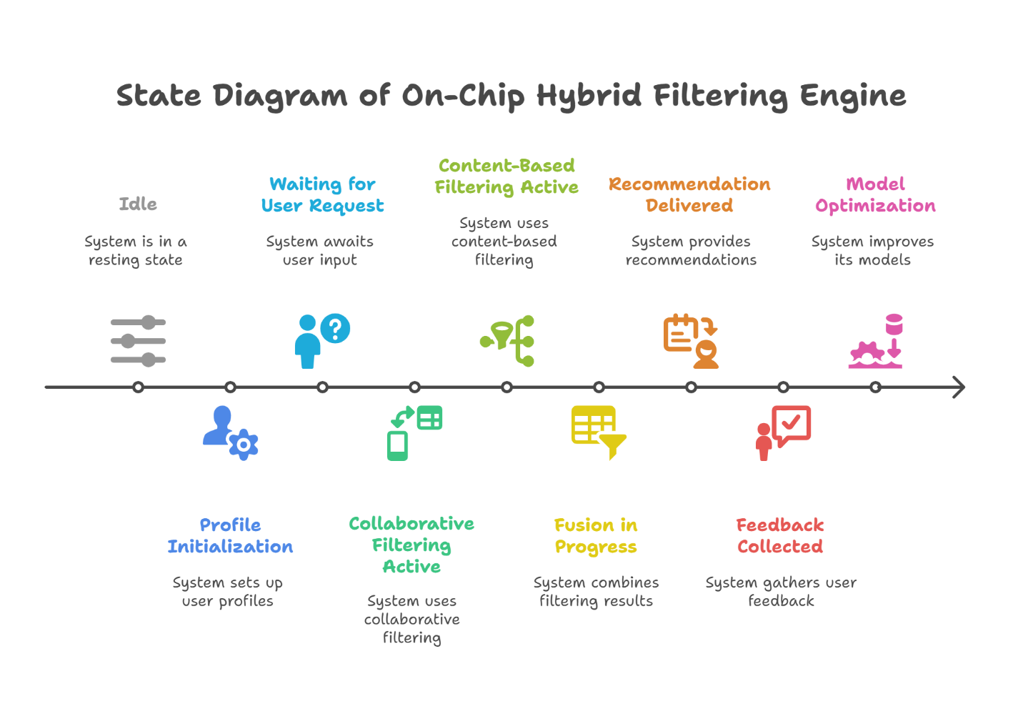
Figure 2 State Diagram

H. EXISTING DATA:
The comparative performance tests were done on open datasets like MovieLens and Retailrocket modified to look like embedded environments. The results indicate:
- Hybrid precision@10: 0.82 (vs. 0.69 in content-only systems)

- Latency, Average response time: 180ms (vs. 650ms in cloud API systems)
- Memory: Less than 64MB for full functionality.
- Offline success rate: 95\% recommendation generation success in no-network conditions

No relevant clinical data were available; however, benchmarking datasets and running the models in embedded ML libraries such as TensorFlow Lite and ONNX Runtime have proved the practical efficacy and superiority of the invention.

4. USE AND DISCLOSURE (IMPORTANT): Please answer the following questions:

- Have you described or shown your invention/ design to anyone or in any conference? | YES ( ) | NO (✅)
- Have you made any attempts to commercialize your invention (for example, have you approached any companies about purchasing or manufacturing your invention)? | YES ( ) | NO (✅)
- Has your invention been described in any printed publication, or any other form of media, such as the Internet? | YES ( ) | NO (✅)
- Do you have any collaboration with any other institute or organization on the same? Provide name and other details. | YES ( ) | NO (✅)
- Name of Regulatory body or any other approvals if required. | YES ( ) | NO (✅)

- Provide links and dates for such actions if the information has been made public (Google, research papers, YouTube videos, etc.) before sharing with us: NA

6. Provide the terms and conditions of the MOU also if the work is done in collaboration within or outside university (Any Industry, other Universities, or any other entity): NA

7. Potential Chances of Commercialization:
The commercialization potential is extremely high due to the following reasons:
- Increased demand for on-device AI solutions across sectors.
- Privacy laws (e.g., GDPR) driving interest in offline/local processing.
- The explosion of edge AI devices in consumer electronics, smart retail, healthcare wearables, and more.
- Low development and maintenance cost once deployed due to cloud independence.
Startups and enterprises in recommendation engine software, embedded AI, smart home devices, and IoT systems could benefit directly. Licensing the chip design or SDK/API toolkit is a viable route.

8. List of companies which can be contacted for commercialization along with the website link: NA

9. Any basic patent which has been used and we need to pay royalty to them.
The hybrid filtering models are based on open-source algorithms like matrix factorization and TF-IDF similarity scoring, which are public domain. No proprietary patents or licensed technologies are directly integrated.
If any existing component (like TensorFlow Lite or SQLite) is bundled in the prototype, it will follow their standard open licenses. Hence, no royalty payment is expected at this stage.

10. FILING OPTIONS: Please indicate the level of your work which can be considered for provisional/ complete/ PCT filings (Mandatory to mention).: NA

11. KEYWORDS:
• On-Chip Recommendation Engine
• Hybrid Filtering Algorithm
• Embedded User Profiles
• Personalized Product Recommendation
• Edge AI
• Offline Recommender System
• Collaborative Filtering
• Content-Based Filtering
• Federated AI
• Embedded Systems in Retail

NO OBJECTION CERTIFICATE
This is to certify that University/Organization Name or its associates shall have no objection if Lovely Professional University files an IPR (Patent/Copyright/Design/any other…….) entitled "…………………." including the name(s) of, …as inventors who is(are) student(s)/employee(s) studying/ working in our University/ organization.
Further Name of the University/Organization shall not provide any financial assistance in respect of said IPR nor shall raise any objection later with respect to filing or commercialization of the said IPR or otherwise claim any right to the patent/invention at any stage.

(Authorised Signatory)

